PROJECTTEMPLATE

I.INTRODUCTION

* 1. **OVERVIEW**

A property management system is software application for the operations of hospitalityaccommodations and commercial residential rental properties PMS is also used in manufacturingindustries, local government andmanufacturing

* 1. **PURPOSE**

Track emails, calls and set tasks to connect with the right buyers, sellers and renters at the righttime. Integrate tools to manage email campaigns and accelerate deal cycles. work anywhere with thesalesforce mobile app. Integrate mail chimp to manage email marketing campaigns with current and pastclients.

1. PROBLEMDEINITIONANDDESIGNTHINKING
   1. EMPATHYMAP

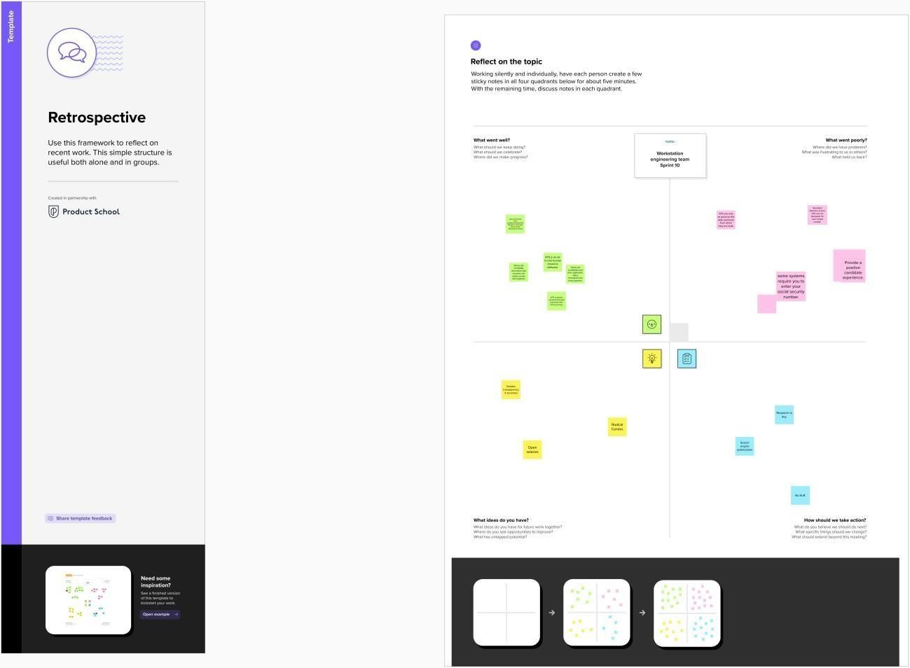

* 1. **IDEATIONANDBRAINSTORMINGMAP**

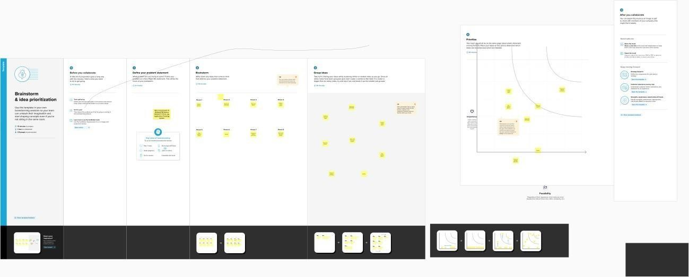

1. **Result**
   1. **DataModel**

|  |  |  |  |  |  |
| --- | --- | --- | --- | --- | --- |
| OBJECTNAME | FIELDSINTHEOBJECT | | | | |
| StandardObject |  | | | | |
|  | Fieldlabel | Datatype | |  |
| Users | Text | |
| Contracts | Text | |
|  | | | | |
| CustomObject |  | | | | |
|  | FieldName | | Datatype |  |
| Buy | | Discount |
| Rent | | City |
|  | | | | |

3.2**Activityandscreenshot**

Milestone1: Creatingdeveloperaccount

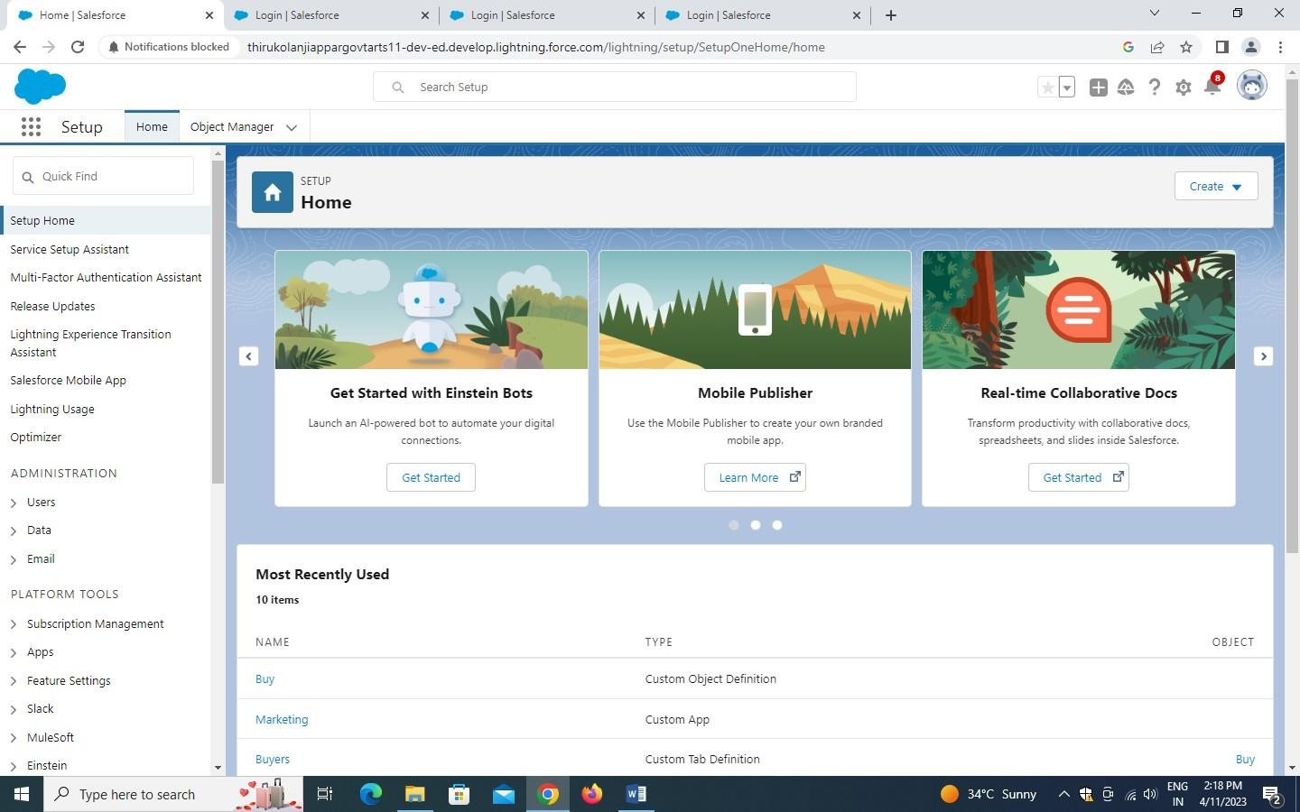

Milestone2:

Activity1: CreatingaObject

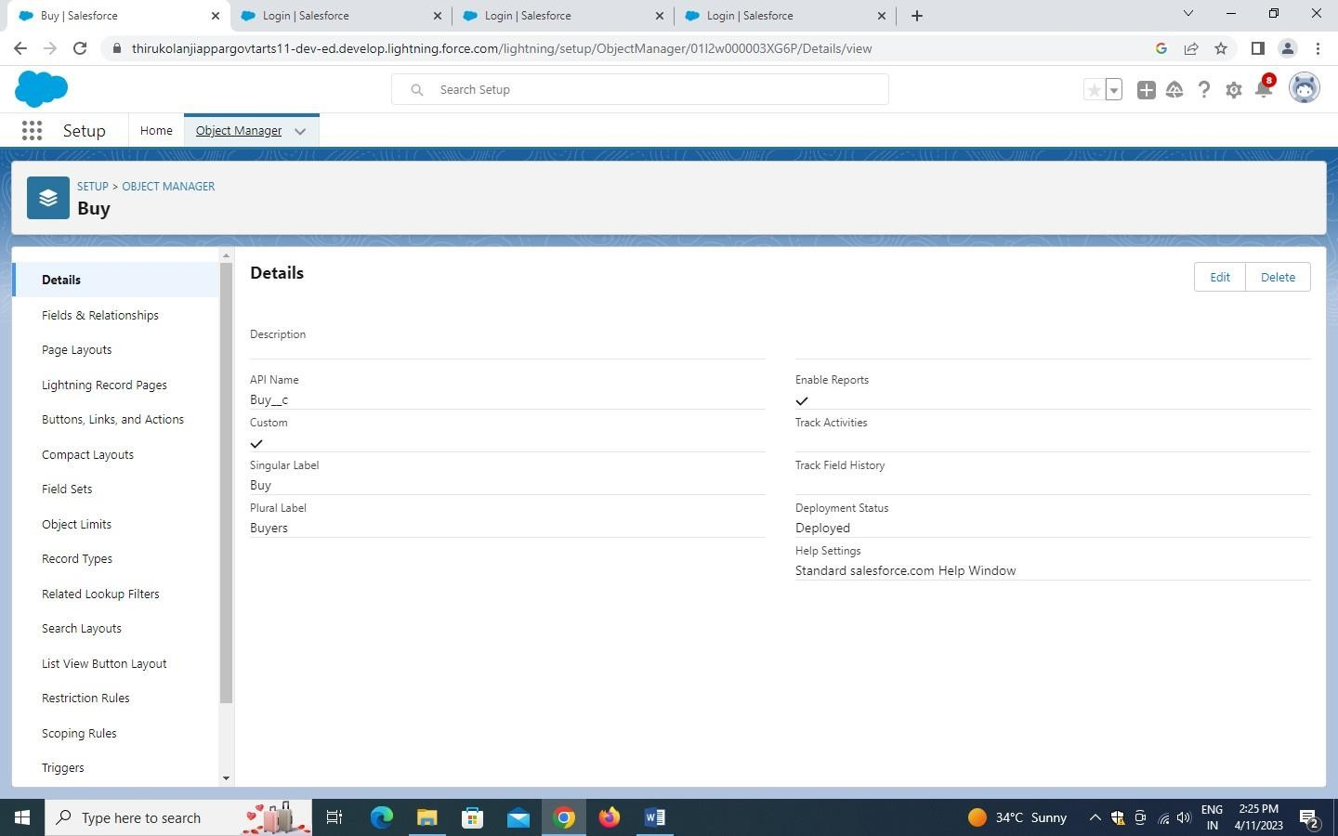

Activity2: CreateObjectBuy

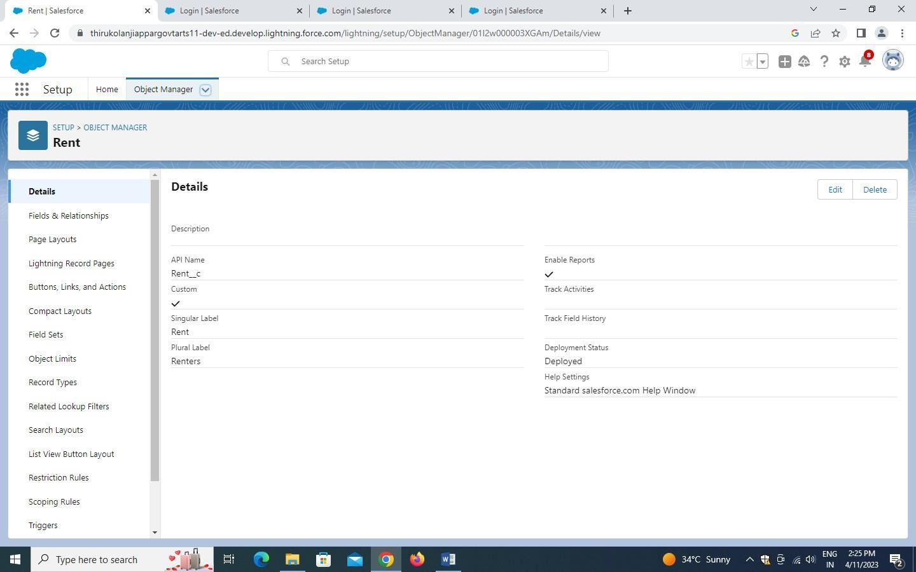

Activity3: CreateObjectRent

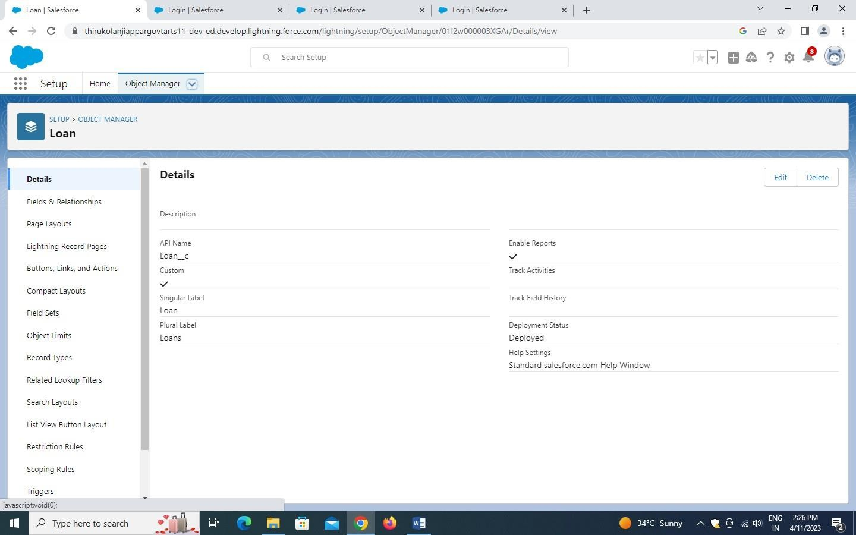

Milestone3:Tab

Activity1: CreatethelightningTab

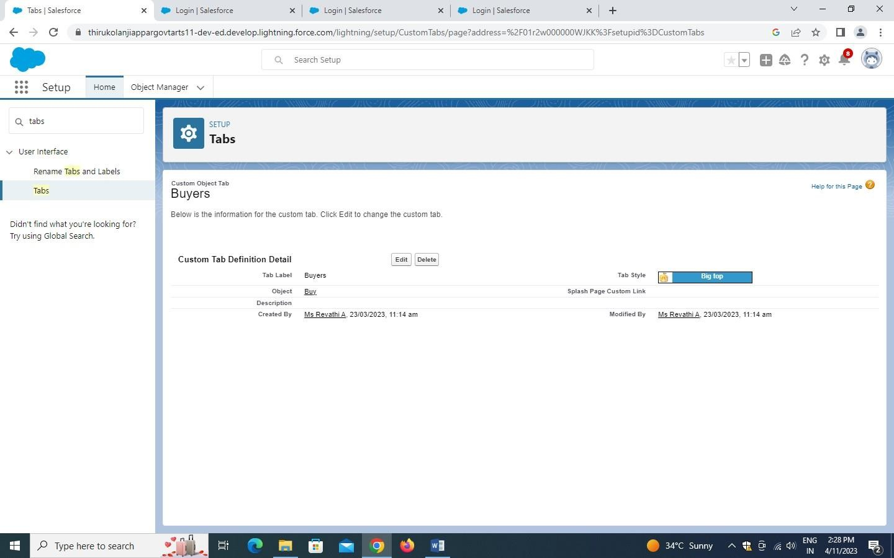

Activity2: CreateaTab(Loan)

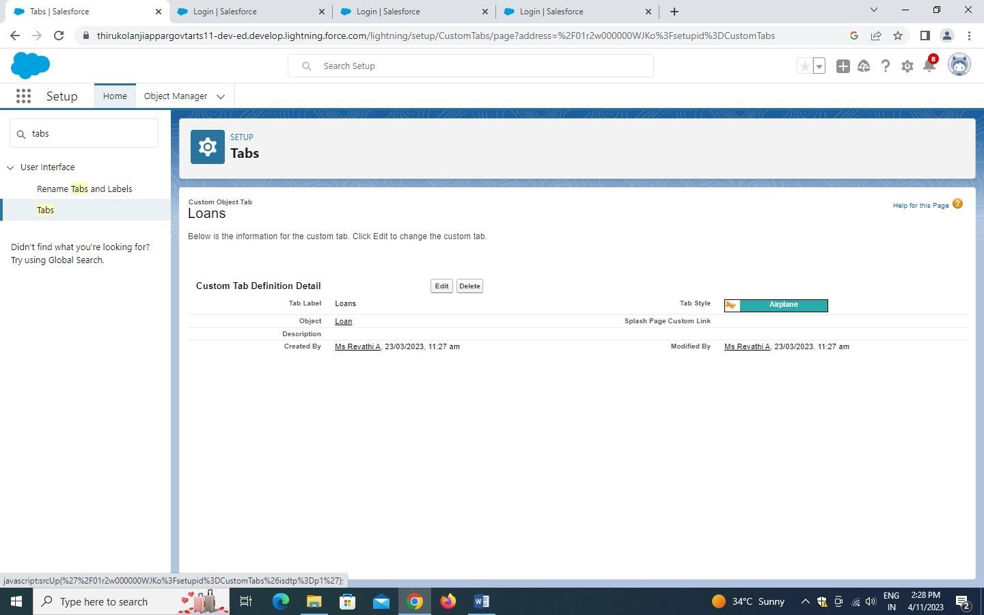

Activity3: CreateaTab(Rent)

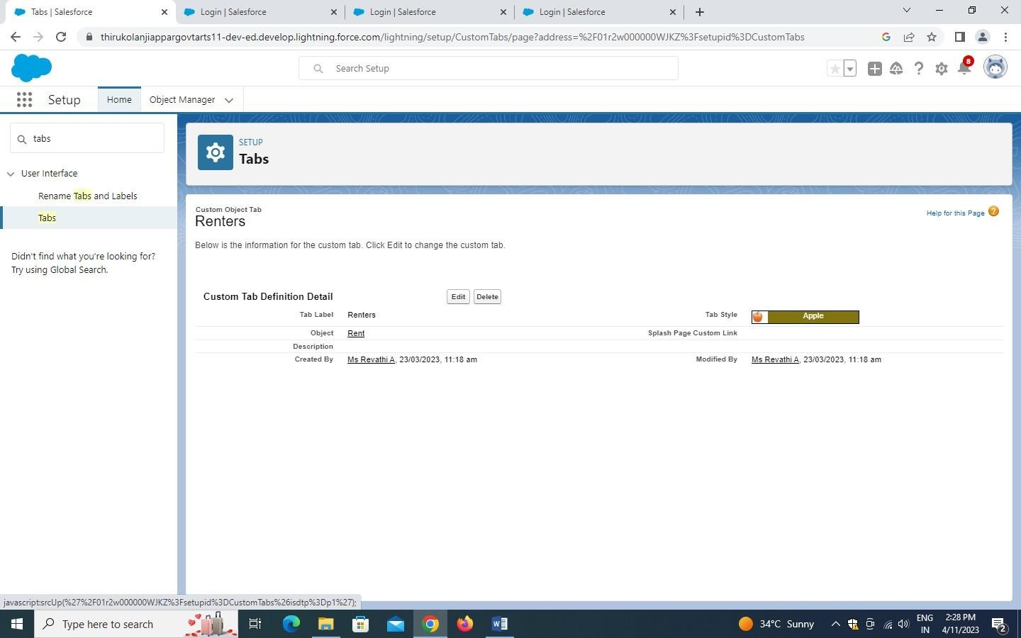

Milestone4:TheLightningApp

Activity1: CreatethelightningApp

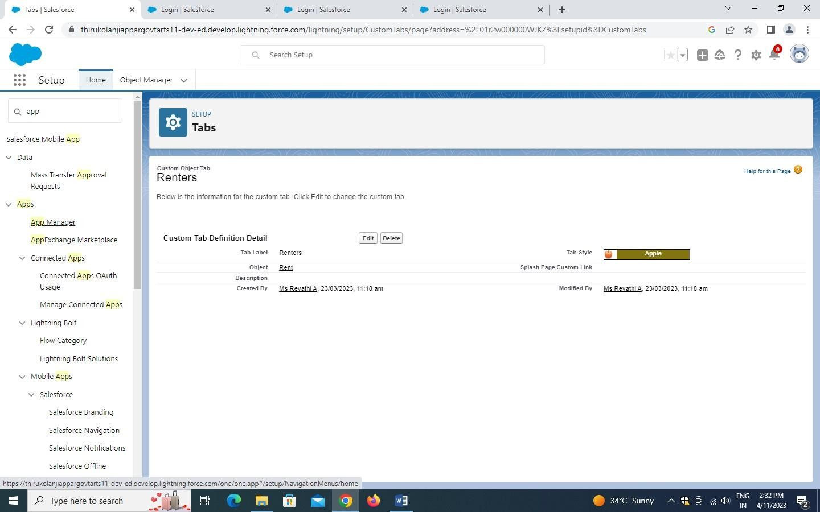

Milestone5:Fields

Activity:1 CreatefieldforLoan

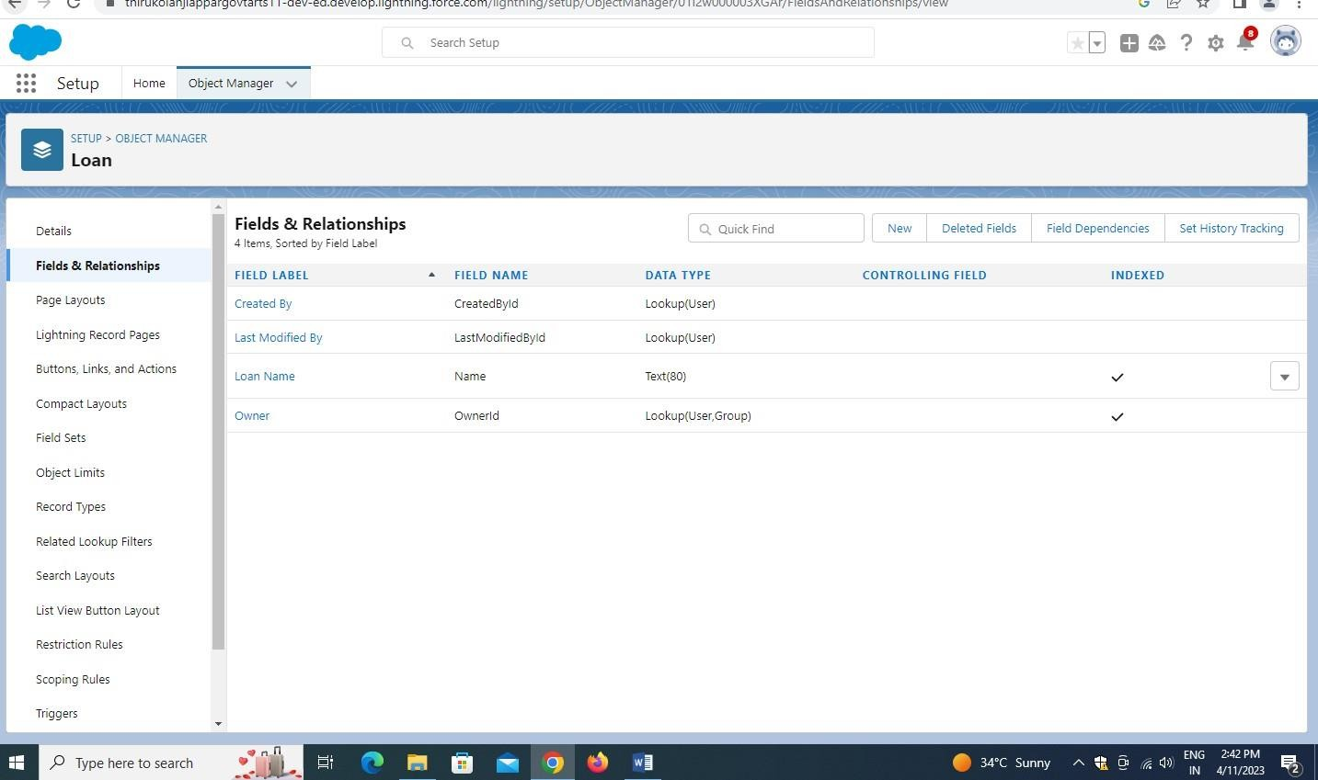

Activity2: CreatefieldforRent

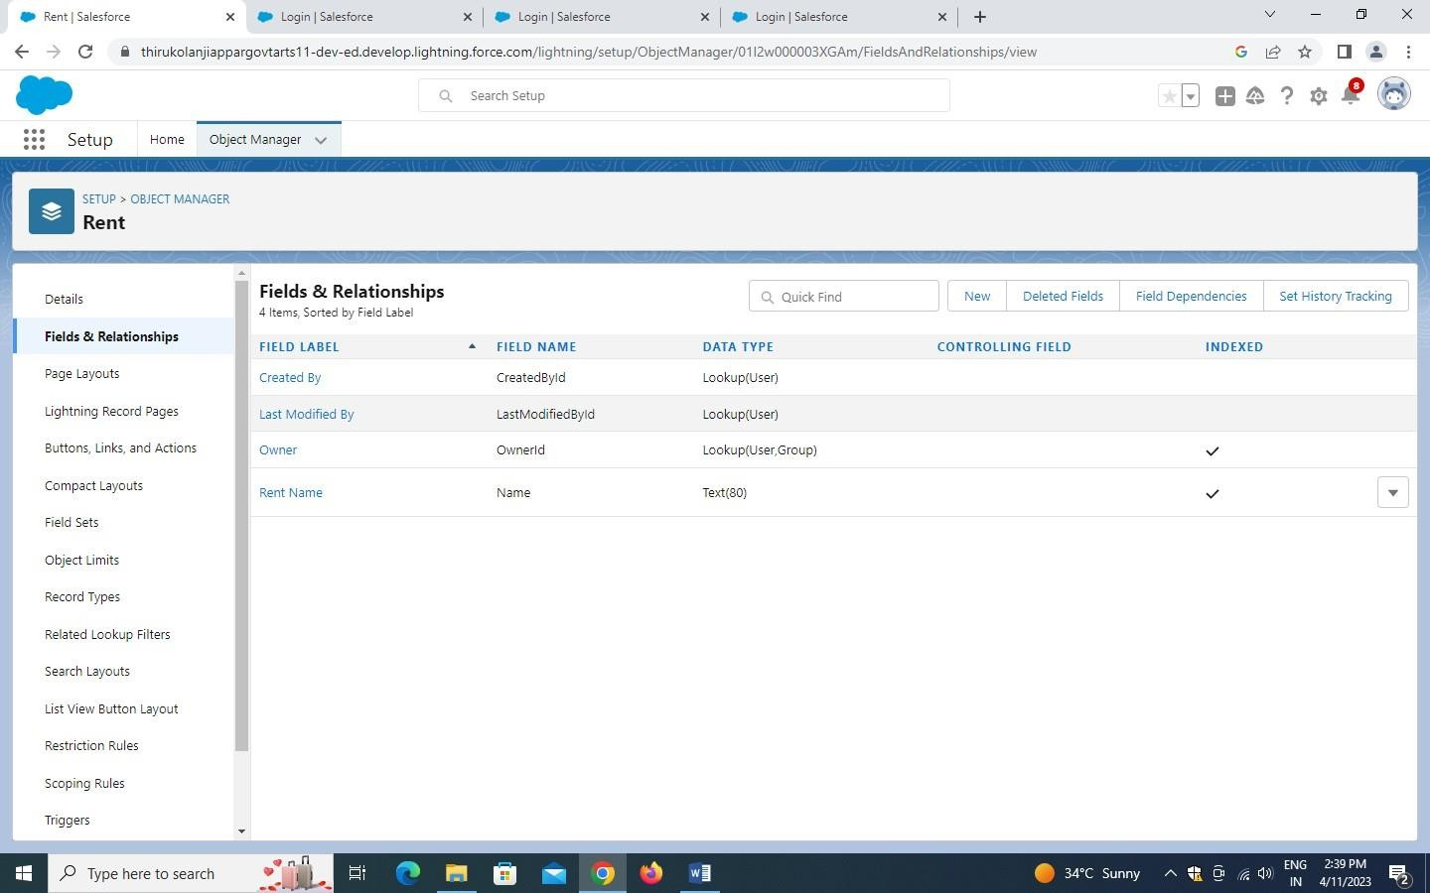

Activity3: Createtheremainingfield

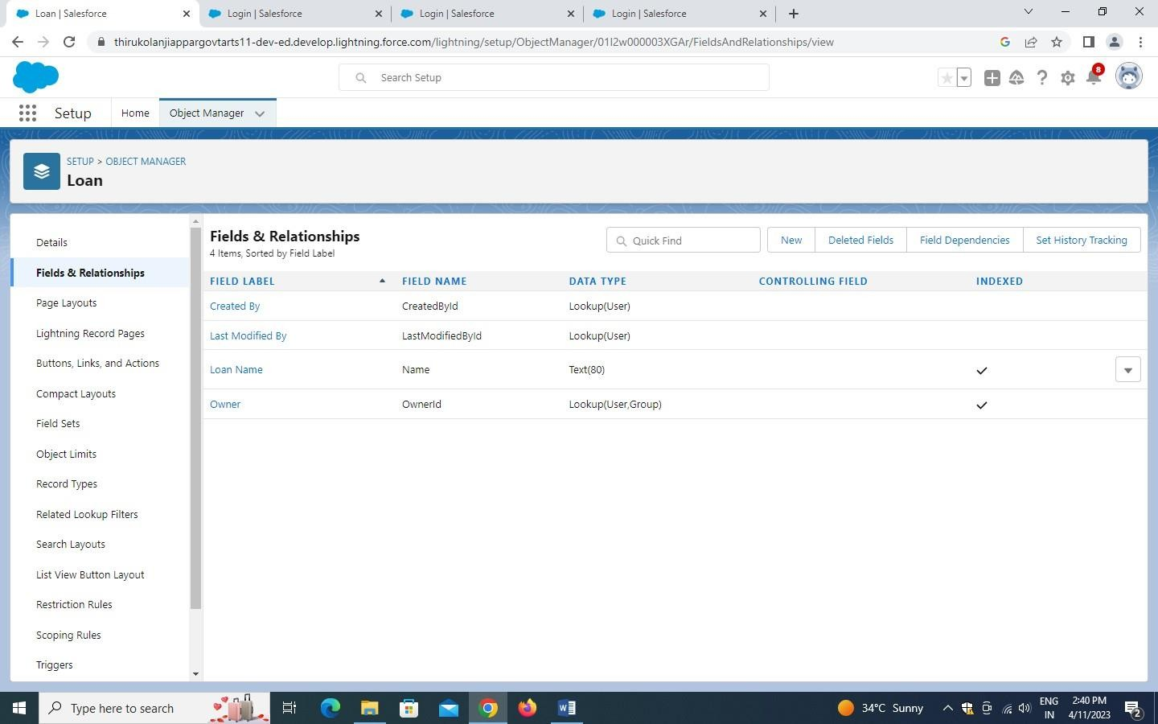

Activity4: CreateFieldforLead

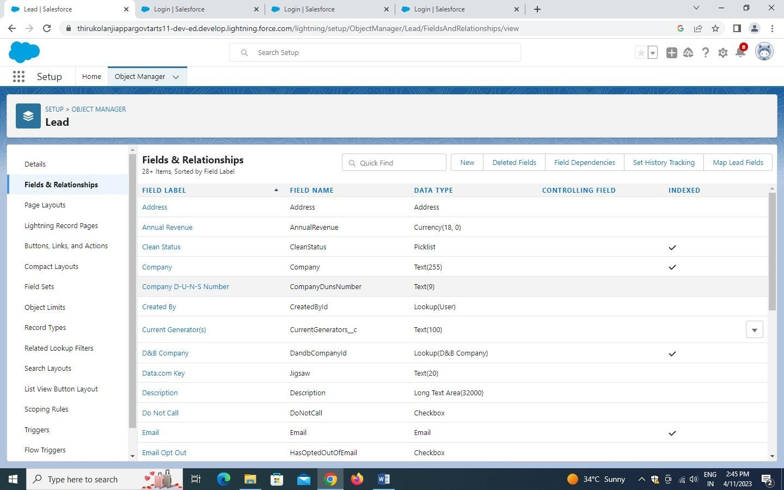

Milestone6:Profile

Activity1: Createnewprofile

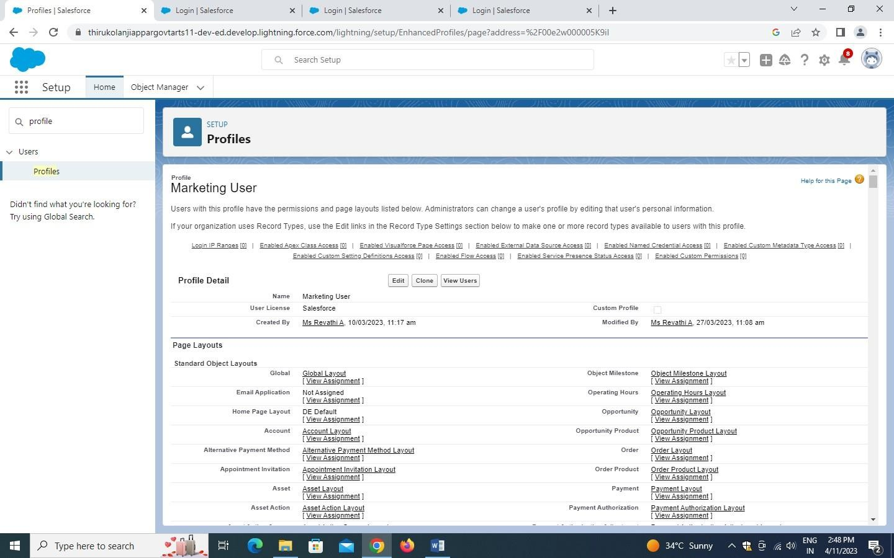

Activity2: CreateMarketing

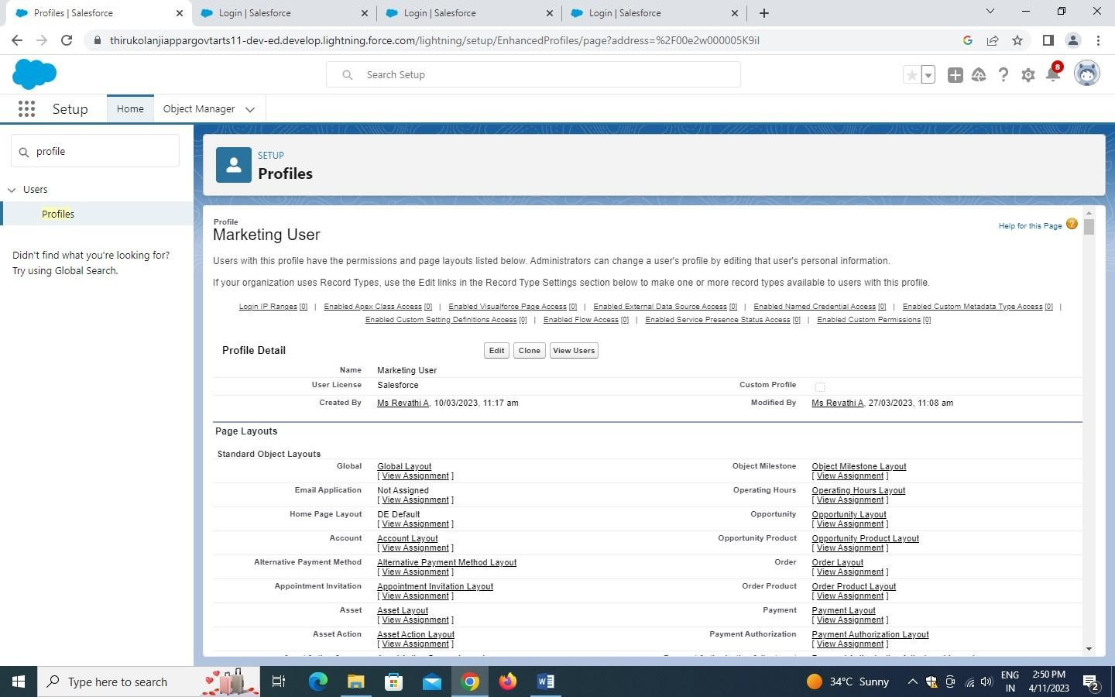

Milestone 7: New userActivity1: CreateUser

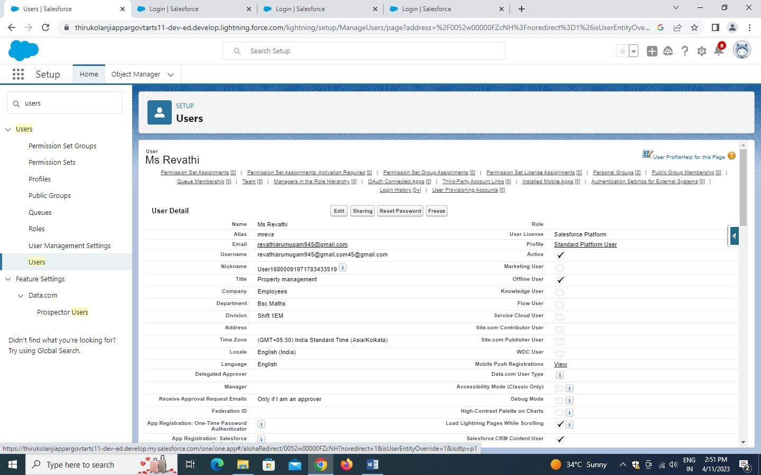

Milestone8:Permissionsets

Activity1: CreatethePermissionSets

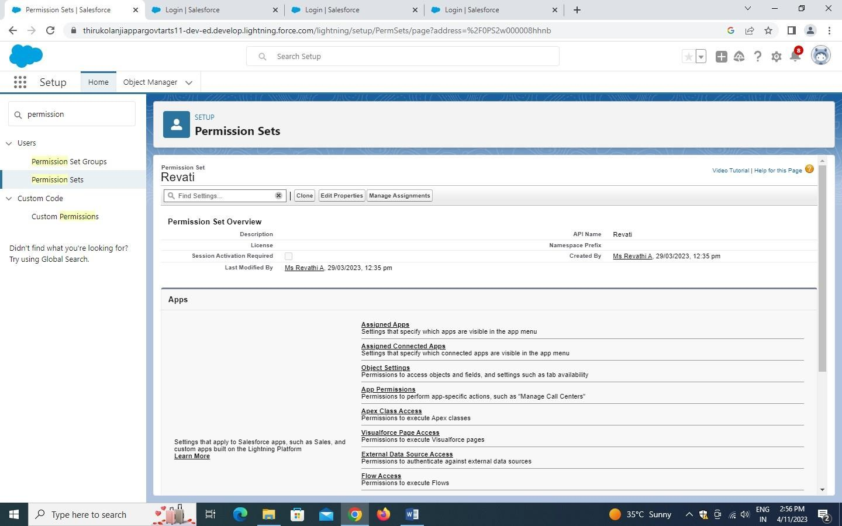

Milestone 9: Set up for OWDActivity1: CreateOWDSetting

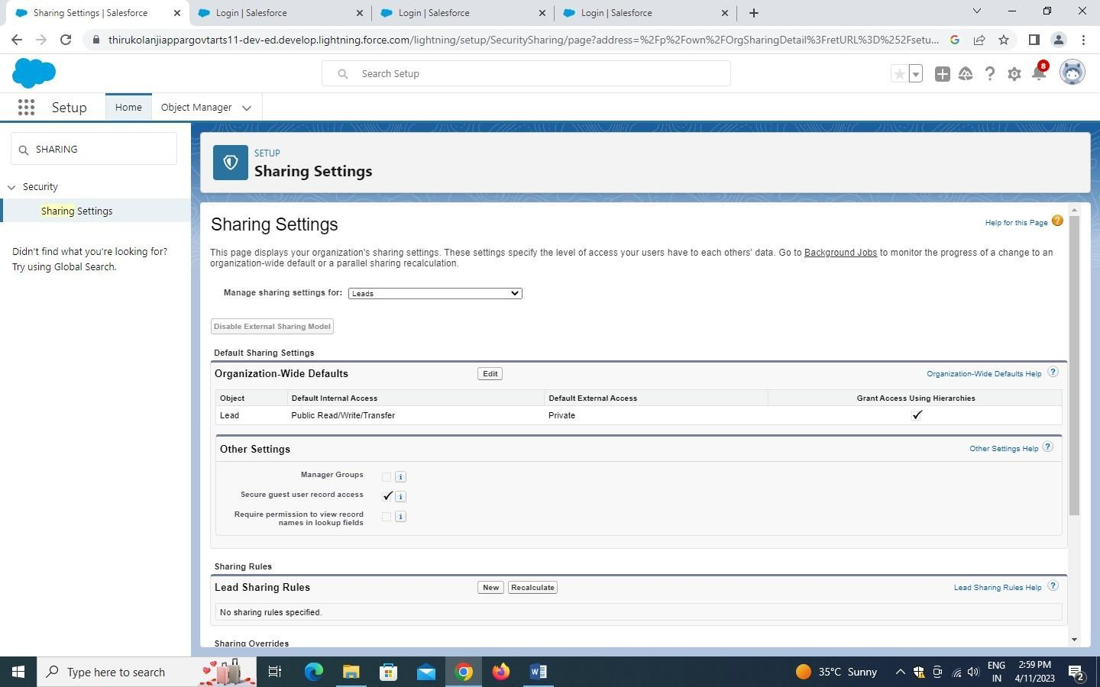

Milestone10:Report

Activity1: CreateReport

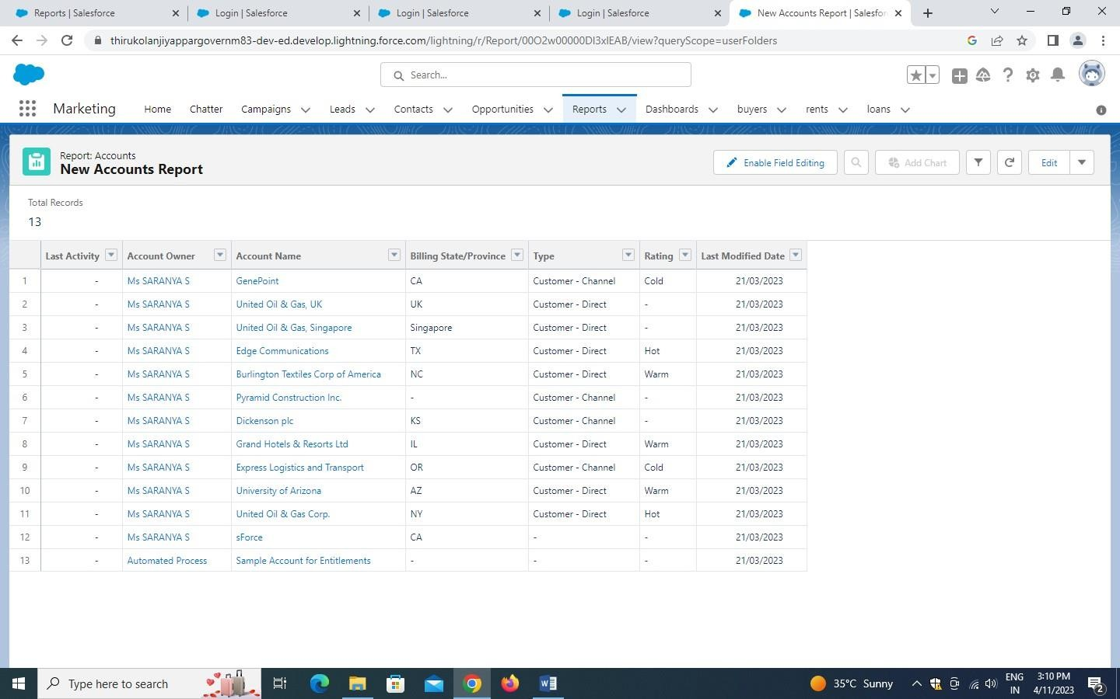

Milestone11:Dashboard

Activity1: CreateDashboard

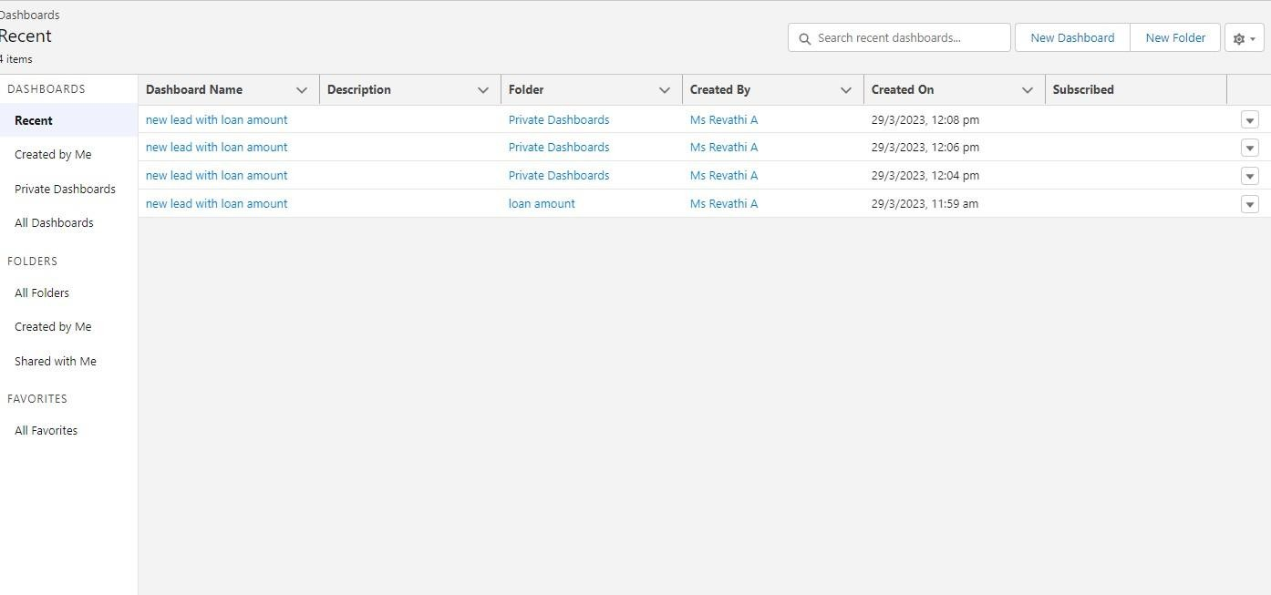

1. TrailheadProfilePublicURL

TEAMLEAD–.A.CHITRA

<https://trailblazer.me/id/cayyasamy>

TEAMMEMBER1-.A.AARTHI

<https://trailblazer.me/id/aarthi2003>

TEAMMEMBER2-.V.GAYATHRI

<https://trailblazer.me/id/haras18>

TEAMMEMBER3–S.SANTHIYA

<https://trailblazer.me/id/mmageshmagi02>

1. ADVANTAGESANDDISADVANTAGE

ADVANTAGE:

A property management system is integrated into every department within a hotel,allowing you to communicate effectively with both employees or outside contractors whilekeeping an eye on revenue inventory, or sales. automating routine tasks can save timer for bothyou and your employees- housekeeping assignments, maintenance requests, reservation manifestsand nightlyaudits areavailable at the touch abutton.

DISADVANTAGE:

Time-consumingifyou choosethewrongsystem.Mightseem expensive for asmallbusiness.

Training(costandtime).

1. APPLICATIONS

Applicationmanagement servicesareanenterprise-wideendeavorprovidinggovernancedesigned to ensure applications run at peak performance and as efficiently as possible, from theend user experience to integration with enterprise back office functions such as database, ERP,andSaaScloud

1. CONCLUSION

Property management system software is very crucial for all the hotels, especially operaPMS constitutes the most appropriate PMS Software for Hilton Athens. It is user friendlyconnectswithCentralReservationSystem,Point ofSaleetc.andprovides allthetoolsthehotel

needs in order to operate effectively. The disadvantages of the Opera PMS can be improvedeasilyandasitwasmentionedbeforearecommendationistheupgradeoOperaV5toOpera9.

1. FUTURESCOPE

The global Real Estate Management software market is geographically divided into regionssuch as North America, Latin America, Europe, Asia Pacific, the Middle East, and Africa.The report covers all aspects of the regional and global markets from manufacturing andcustomersharesto marketsizeandmarket share,import andexport ratiossupplyanddemandratios, consumer demand ratios, technological improvements and R&D activate. The reportalsocoversstrongmarketpresence in everyregion.